Bureaucracy Infographic

Objective: Understand how has the federal bureaucracy changed over U.S. history.
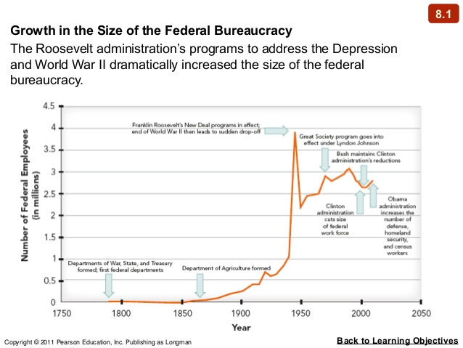
- Define US Federal Bureaucracy:
- What is the big picture story of this chart?
- Why do you think the bureaucracy has changed so much?
- What are two consequences of the growth of the US bureaucracy?
- Considering that we have gone from an agrarian, preindustrial, rural society (see chart below) to the crazy high tech world of today, is it a logical thing that our bureaucracy has grown? Why or why not?

Year | Per Capita GDP | GDP  In Millions | Life Expectancy | National bird | 4th largest city by pop. | Total US pop.
1789* | $1,107 | $189 | 36 years | Eagle | Charleston at 16,359 | 4 million
2014** | $50,010 | $17,348,100 | 79 years | Eagle | Houston, TX  at 2,099,451 | 318.86 million
*The United States ratified the Constitution, inaugurated its first president, and also the first Macaroni Machine was brought to the United States by Thomas Jefferson.
**The biggest hit of 2014 was Pharrell William’s Happy

