Your Name: ____________________________________
Think and Do: Lynching Statistics of the South
Directions: Study the chart, then answer the questions that follow in COMPLETE SENTENCES.
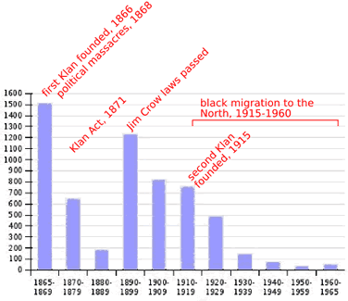

- In what approximate years were the first and second Ku Klux Klan’s founded?

- Why do you think lynching started to decrease significantly after about 1920?

- Why do you think lynching was at one of its highest points the Jim Crow laws were passed?

